**Sunflowers’ Curriculum**

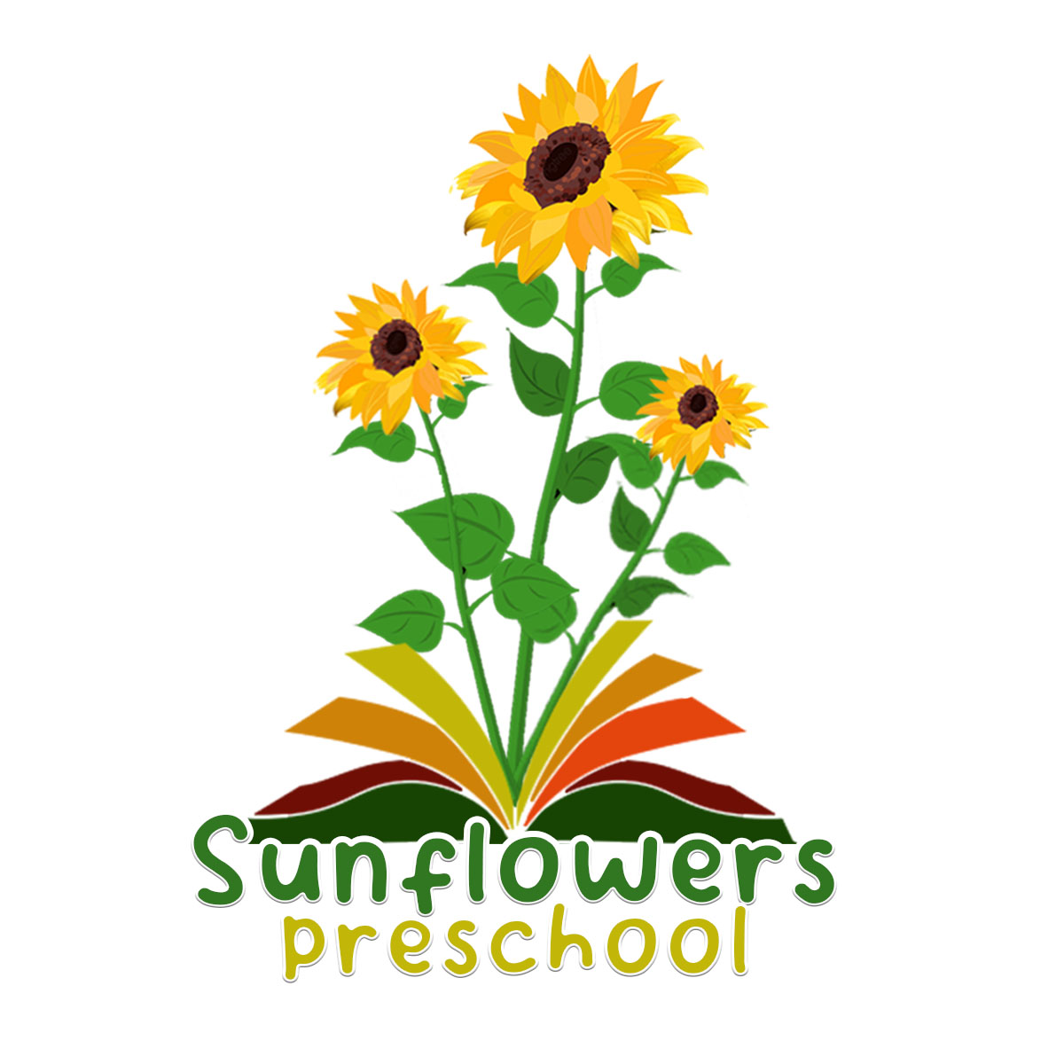

It is very important that at Sunflowers Preschool all our children leave us with the foundation skills of being confident, creative, independent and resilient, by having a strong sense of self-worth and self-esteem and the ability to begin to manage their own risk so that they are happy, confident and secure to start their new chapter in reception. We wish to aid children in discovering a life-long love of learning by covering all 7 areas of learning, which are; Communication and Language, Personal, Social and Emotional Development, Physical Development, Literacy, Mathematics, Understanding the World and Expressive Arts and Design.

**We will do this by:**

* Facilitating the learning environment to encourage the children to experience, explore, ask questions and use their imagination, through a variety of sensory learning styles.
* Encourage children to explore and appreciate nature, natural materials, living things and begin to understand our impact (positive and negative) on the world, both locally and globally.
* Through a person/child centred approach, give the children confidence/support to ask for help and be able to communicate their needs and wants.
* Supporting children to be independent; using the toilet, washing and drying their own hands, wiping their noses with a tissue, putting on and taking off their own shoes and coats, pouring their own drinks and opening/closing their own lunch boxes.
* Supporting children to follow boundaries, routines and instructions.
* Promoting speech and language skills by encouraging an interest in books, listening to stories, group listening activities, role play, songs and games.
* Giving children a voice and empowering them to make their own choices and decisions, while learning to understand and respect the decisions of others.
* Giving children opportunities to manage their own risk through climbing, jumping and balancing, using encouragement and praise.
* Provide mark making and fine motor skill opportunities to support children’s hand muscles for when they are developmentally ready for writing.
* Give the children opportunities to develop a fundamental understanding of maths skills on which to build and develop, by counting, grouping, use of games and using shape within the environment.
* Supporting children’s sharing and turn taking skills with adult led games and activities.
* Giving children opportunities to explore and engage in activities they may not usually have the opportunity to do.
* Introducing children to the diverse nature of our community, the world, and the people within it; by sharing celebrations, cultural differences, individual differences, show & tell and occasional adult visits.
* Give children support to understand, develop and strengthen important attachments within their unique family dynamics and to build positive relationships between adults and peers which shape their social world; through positive role modelling, role play, key worker approach, books and games.
* Encouraging children to be inquisitive, ask ‘why?’, build their resilience and find alternative methods to problem solve.
* Develop an environment where it is okay to make mistakes and explore how we can learn from them. To FAIL is only the First Attempt in Learning.
* Introducing children to creative art, drama and dance. Encouraging involvement through use of craft materials, recycling/upcycling, adult visits, games, poems, music, musical instruments and roleplay.
* Introduce children to the counting of voices, with regards to choice. How to lose gracefully, as well as to succeed. How to celebrate the success of others, encouraging participation and showing that to be unsuccessful at something allows us to find a better way, thus building resilience.