Risk Assessment Policy
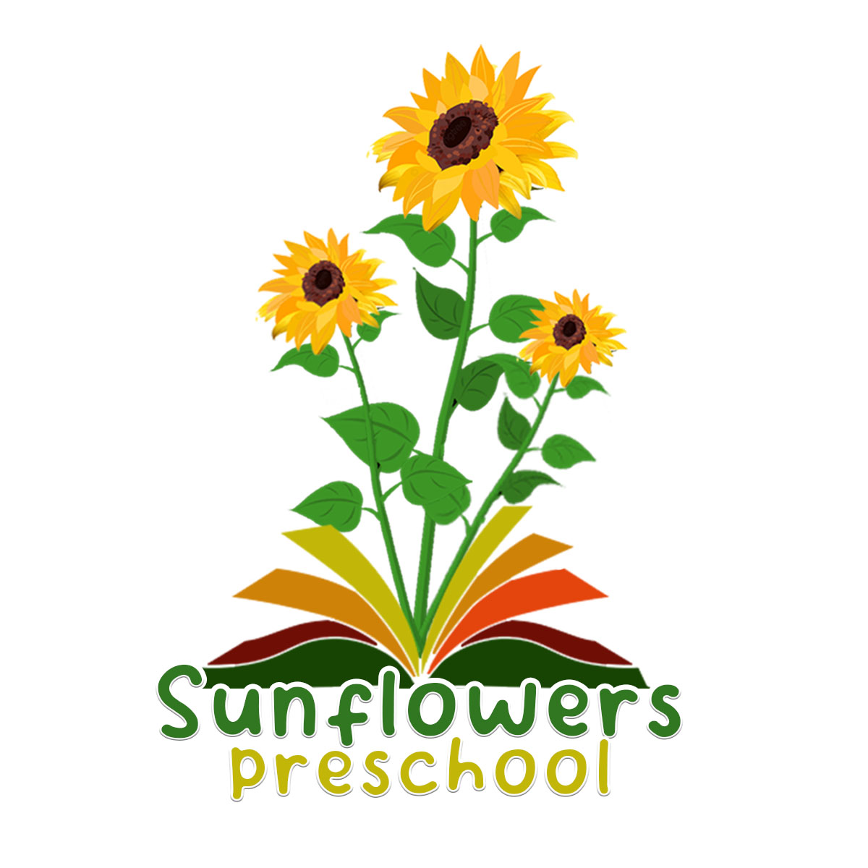
Sunflowers Preschool believes that the health and safety of children is of paramount importance. We make our setting a safe and healthy place for children, parents, staff and volunteers by assessing and minimising the hazards and risks to enable the children to thrive in a healthy and safe environment.
The basis of this policy is risk assessment.
- Identification of risk; where it is and what it is?
- Who is at risk; childcare staff, children, parents, cleaners etc?
- Assessment as to the level of risk as high, medium, low. This is both the risk of the likelihood of it happening, as well as the possible impact if it did.
- Control measures to reduce/eliminate risk: What will you need to do, or ensure others will do, in order to reduce that risk?
- Monitoring and review: How do you know if what you have said is working, or is thorough enough? If it is not working, it will need to be amended, or maybe there is a better solution.
Procedures.
- Our risk assessment process covers adults and children and includes;
- Checking for and noting hazards and risk both indoors and outside, and in our premises and for activities.
- Assessing the level of risk and who might be affected.
- Deciding which areas need attention; and
- Developing an action plan that specifies the action required, the time-scales for action, the person responsible for the action and any funding required.
- Where more than five staff and volunteers are employed and the risk assessment is written and reviewed regularly.
- We maintain lists of health and safety issues, which are checked daily before the session begins.
- A named member of staff will be responsible for Risk Assessment and Safety and staff training in these areas. The named member of staff is Angela Guy.
- All staff to be aware of the daily checklist and to carry out accordingly. The checklist will need to be signed daily.
- A full Risk Assessment will be carried out once a year and staff made aware of any significant changes or hazards.

