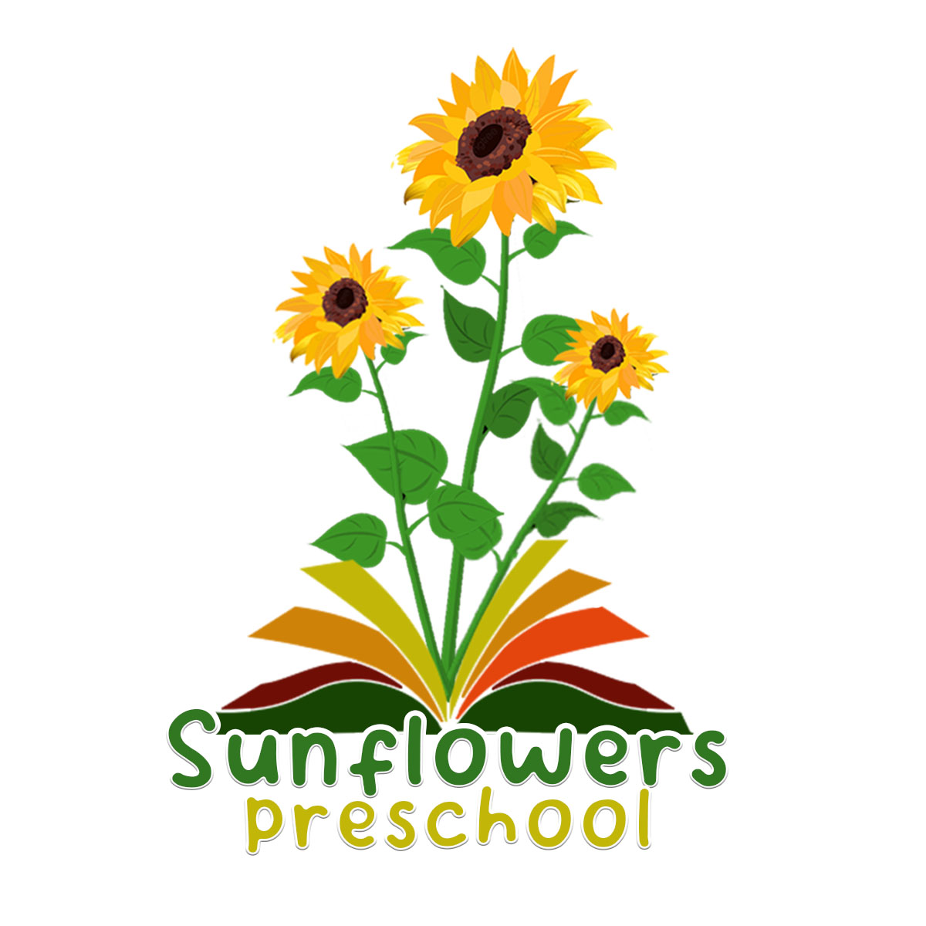
04 Health policy

Alongside associated procedures in 04.1-04.7 Health, this policy was adopted by Sunflowers Preschool on 1st September 2026.

Aim
Sunflowers Preschool is a suitable, clean, and safe place for children to be cared for, where they can grow and learn. They meet all statutory requirements for promoting health and hygiene and fulfil the criteria for meeting the relevant Early Years Foundation Stage Safeguarding and Welfare requirements.
Objectives
We promote health through:
- Ensuring emergency and first aid treatment is given where necessary.
- Ensuring that medicine necessary to maintain health is given correctly and in accordance with legal requirements.
- Identifying allergies and preventing contact with the allergenic substance.
- Having ongoing discussions with parents/carers to develop allergy action plans for managing individual children’s known allergies and intolerances.
- Ensuring that all staff are aware of the symptoms and treatments for allergies and anaphylaxis and that children can develop these at any time, especially during weaning.
- Ensuring that all staff know the difference between allergies and intolerances.
- Identifying food ingredients that contain recognised allergens and displaying this information for parents/carers.
- Identifying and promoting health through taking the necessary steps to prevent the spread of infection and taking appropriate action when children are ill.
- Ensuring that food is prepared for children in a way that prevents choking.
- Ensuring that children are always in sight and hearing of a staff member, who is a paediatric first aider, whilst eating and the staff member is sat facing the children.
- Recording all choking incidents that requires intervention.
- Promoting healthy lifestyle choices through diet and exercise.
- Pandemic flu planning or illness outbreak management as per DfE and World Health Organisation (WHO) guidance.
Legal references
Medicines Act (1968)
The Reporting of Injuries, Diseases and Dangerous Occurrences Regulations 2013 (RIDDOR)
Control of Substances Hazardous to Health (COSHH) Regulations (2002)
Health and Safety (First Aid) Regulations 1981
Food Information Regulations 2014
Early Years Foundation Stage

Further guidance
Accident Record (Alliance Publication)
Allergy action plan
Allergy Awareness in Early Years Certificate Training - Level 2

