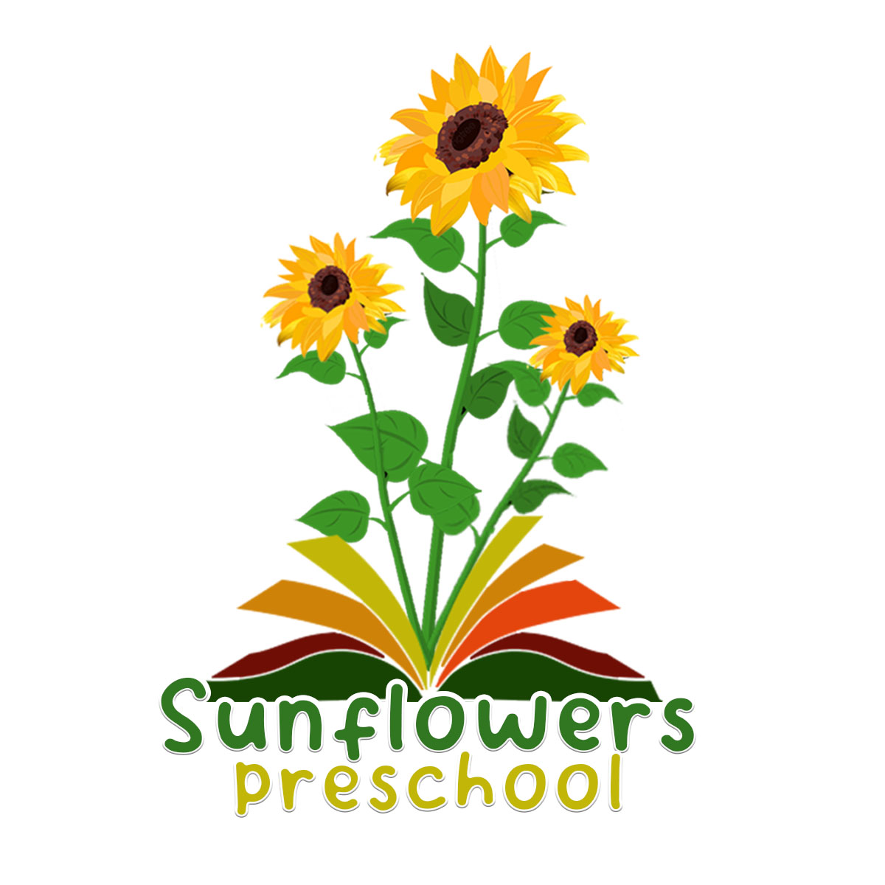

02 Fire safety policy

Alongside associated procedures in 02.1 Fire safety, this policy was adopted by Sunflowers Preschool on 1st September 2026.

Aim
Sunflowers Preschool is a suitable, clean, and safe place for children to be cared for, where they can grow and learn. We meet all statutory requirements about fire safety and fulfil the criteria for meeting the relevant Early Years Foundation Stage Safeguarding and Welfare Requirements.
Objectives
- We recognise that we have a corporate responsibility and a duty of care for those who work in and receive a service from our provision, but individual employees and service users also have a responsibility to ensure their own safety as well as that of others. Risk assessment is the key means through which this is achieved.
- A ‘Responsible Person’ is designated to be accountable for overseeing that the provision is compliant with fire safety laws and regulations.
- Designated fire marshals are trained staff members and will assist the responsible person to monitor fire risks, carry out checks, and assist during evacuations.
- A fire safety risk assessment is regularly carried out by the ‘Responsible Person’ in accordance with the Regulatory Reform (Fire Safety) Order 2005.
- A fire evacuation drill is conducted at least on a termly basis.
- A Fire Log is completed and regularly updated.
Personal Emergency Evacuation Plans (PEEPs) for those who cannot evacuate the building without additional support are implemented and understood by all staff members. Necessary equipment, such as fire extinguishers, fire blankets, and functioning fire detection systems, are in place, and regularly maintained, to promote fire safety.
- Designated Responsible Person is: Angela Guy
- Designated Fire Marshalls are: Angela Guy

Legal references
Regulatory Reform (Fire Safety) Order (2005)
Electricity at Work Regulations (1989)
Early years foundation stage (EYFS)

Further guidance
Fire Safety Record (Alliance Publication)
Fire Safety Risk Assessment: Educational Premises (Gov.uk)
Dynamic Risk Management in the early years (Alliance Publication)
ADD: Fire Safety Awareness (Safer Food Group) on EYA CENTRAL
Emergency planning and response for education, childcare and children's social care settings - GOV.UK

